PROJECT TITLE

LIBRARY MANAGEMENT SYSTEM

NAME

GOKUL K

REG NO

RA2111002010119

DEPARTMENT

MECHANICAL ENGINEERING

SUBMITTED TO

DR. R. RAJKUMAR

DSBS

SCHOOL OF COMPUTING

SRMIST

JANUARY 2022

**ABSRACT** (300 WORDS)

In this article, we will discuss the approach to create an Library Management System where the user has the following options:

1. Add book information.

2. Display book information.

3. To list all books of a given author.

4. To list the title of specified book.

5. To list the count of books in the library.

If the user tries to add a book then the user must have to provide the below specific Information about the book as:

Enter Book Name =

Enter Author Name =

Enter Pages =

Enter Price =

When the user tries to display all books of a particular author then the user must have to enter the name of the author:

Enter author name =

When the user tries to display the title of specified book then the user must have to enter the name of the book.

Enter book name =

The Library management System must be also capable of counting all the books available in the library.

**FLOW CHART**

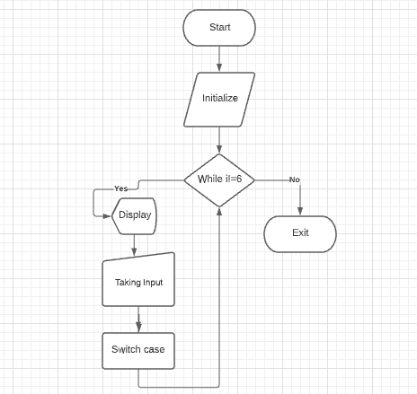

**PROGRAM**

#include<stdio.h>

#include<conio.h>

#include<stdlib.h>

#include<string.h>

struct library

{

char bk_name[30];

char author[30];

int pages;

float price;

};

int main()

{

struct library l[100];

char ar_nm[30],bk_nm[30];

int i,j, keepcount;

i=j=keepcount = 0;

while(j!=6)

{

printf("\n\n ############################################\n ## WELCOME TO LIBRARY MANAGEMENT SYSTEM ##\n ############################################\n");

printf("\n\n1. Add book information\n2. Display book information\n");

printf("3. List all books of given author\n");

printf("4. List the title of specified book\n");

printf("5. List the count of books in the library\n");

printf("6. Exit");

printf ("\n\nEnter one of the above : ");

scanf("%d",&j);

switch (j)

{

/* Add book */

case 1:

printf ("Enter book name = ");

scanf ("%s",l[i].bk_name);

printf ("Enter author name = ");

scanf ("%s",l[i].author);

printf ("Enter pages = ");

scanf ("%d",&l[i].pages);

printf ("Enter price = ");

scanf ("%f",&l[i].price);

keepcount++;

break;

case 2:

printf("you have entered the following information\n");

for(i=0; i<keepcount; i++)

{

printf ("book name = %s",l[i].bk_name);

printf ("\t author name = %s",l[i].author);

printf ("\t pages = %d",l[i].pages);

printf ("\t price = %f",l[i].price);

}

break;

case 3:

printf ("Enter author name : ");

scanf ("%s",ar_nm);

for (i=0; i<keepcount; i++)

{

if (strcmp(ar_nm, l[i].author) == 0)

printf ("%s %s %d %f",l[i].bk_name,l[i].author,l[i].pages,l[i].price);

}

break;

case 4:

printf ("Enter book name : ");

scanf ("%s",bk_nm);

for (i=0; i<keepcount; i++)

{

if (strcmp(bk_nm, l[i].bk_name) == 0)

printf ("%s \t %s \t %d \t %f",l[i].bk_name,l[i].author,l[i].pages,l[i].price);

}

break;

case 5:

printf("\n No of books in library : %d", keepcount);

break;

case 6:

exit (0);

}

}

return 0;

}

**RESULTS**

The program (Library Management System) has been successfully processed and the output is verified.

**SCREENSHOT**

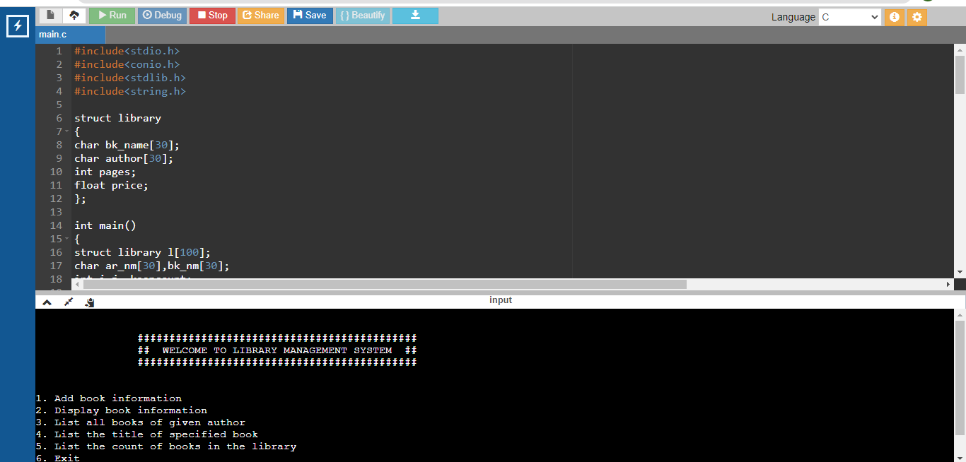

**DECLARATION**

Thanks to me for believing in myself and thanks to friends and the professor.

**RERERENCES**

<https://www.cppbuzz.com/projects/c/library-management-in-c>